For immediate issue: 6 October 2026, 10am
English National Opera presents Gluck's greatest work Iphigénie en Tauride
Directed by Lyndsey Turner
6-14 November 2026 at the London Coliseum
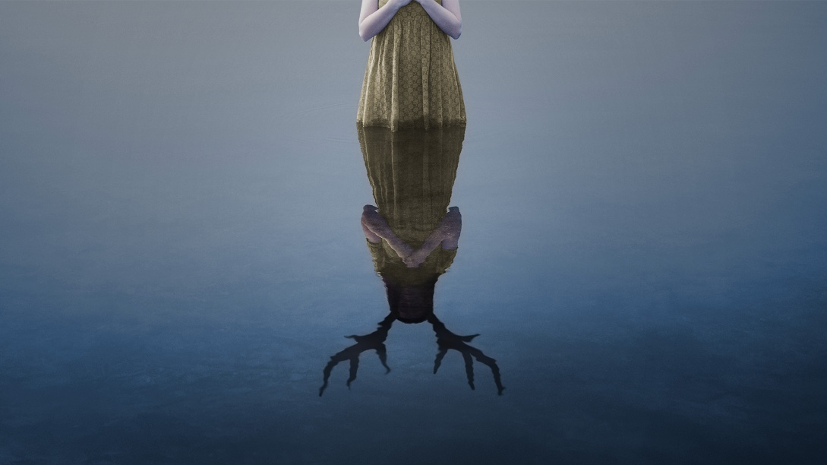
Under 21s can get free tickets to all ENO opera productions at every level of the theatre, and 21-35 year olds can get discounted tickets. Tickets for everyone begin at £25.
This autumn, a new production of Iphigénie en Tauride makes its English National Opera (ENO) premiere at the London Coliseum, running from 6-14 November 2026. Rarely performed but widely regarded as Gluck’s greatest work, the opera follows Iphigénie, secretly saved from sacrifice by the goddess Diana and now serving as her priestess, whose world is upended by the arrival of her tormented brother Oreste. As he seeks release from his persecution, the siblings are drawn towards reconciliation and divine mercy.
Iphigénie en Tauride is directed by the Olivier Award-winning Lyndsey Turner. She returns to ENO following her production of Noye’s Fludde in 2019 which went on to win an Olivier Award, and her recent success with the Almeida and West End production of 1536 which was presented with ‘characteristic finesse’ (The Independent).
The award-winning Orchestra of ENO will be conducted by Baroque specialist David Bates, who makes his ENO debut. Bates has dedicated his internationally acclaimed career to bringing long-forgotten repertoire back to life and has attracted praise for his ‘superbly engaging, theatrically thrilling’ performances (Gramophone).
At the emotional heart of Iphigénie en Tauride is the relationship between brother and sister, Iphigénie and Oreste. Leading the cast as Iphigénie is mezzo-soprano Christine Rice, following her standout performance in ENO’s Olivier Award-winning production of Dead Man Walking (2025) as Sister Helen Prejean. Widely regarded as one of the leading British mezzo-sopranos, she was appointed MBE in the 2023 New Year Honours for services to opera and has performed at many of the world's most renowned opera houses throughout her distinguished career.
Performing the role of her brother, Oreste, is baritone Jacques Imbrailo who also makes a welcome return to ENO following his recent performance as Owen Hart in Dead Man Walking. A former ROH Jette Parker Young Artist, Imbrailo won the Audience Prize at the 2007 BBC Cardiff Singer of the World competition and has since established himself as one of opera’s most sought-after artists.
They will be joined by tenor Nick Pritchard as Pylade, and baritone Morgan Pearse as Thoas. Former Harewood Artist and mezzo-soprano Amy Holyland will perform the role of Second Priestess. The cast is completed by Harewood Artists and sopranos Olivia Rose Tringham and Ava Dodd, who perform the roles of First Priestess and A Greek Woman respectively, and chorus member Robert Winslade Anderson, bass, as Scythian Priest, alongside the Chorus of ENO.
Iphigénie en Tauride will be performed in its original French libretto by Nicolas-François Guillard, with English surtitles. The creative team is completed by Soutra Gilmour as the Set and Costume Designer, and Tim Mitchell as the Lighting Designer.
Iphigénie en Tauride runs at the London Coliseum from 6-14 November 2026 for four performances.
-ENDS-

Notes to Editors:

For more information or to request an interview, please contact:
Natasha Haddad, Senior Communications Manager, English National Opera -
nhaddad@eno.org | +44 20 7845 9426

Iphigénie en Tauride
Composer: Christoph Willibald Gluck
Librettist: Nicolas-François Guillard
Director: Lyndsey Turner
Conductor: David Bates

Performances:
London Coliseum
6, 9, 11 Nov at 19.30. 14 Nov at 18.00.

Running Time: 2 hours 20 minutes (with one interval)
Performed in its original French libretto, with English surtitle.
Tickets start from £25 (including all fees).

Artwork [Password: 2627]: https://englishnationalopera.smugmug.com/ENOs-202627-Season-/202627-Season-Production-Artwork-

About English National Opera:
English National Opera (ENO) is one of the UK’s leading opera companies, dedicated to creating extraordinary encounters with opera, on stage and beyond. Performing in English and presenting bold, imaginative productions in an inclusive environment, ENO brings together outstanding artists, musicians and creative teams to tell powerful stories to the widest possible audience.

ENO is a dual-centre opera company, presenting a season at the iconic London Coliseum every year alongside dynamic work in Greater Manchester as part of its pioneering partnership with the city-region. Across the country, ENO runs a wide-ranging programme of learning, participation, creative health and community engagement that supports emerging talent and opens opera to people of all ages and backgrounds.

Founded in 1931 as Sadlers Wells Opera, ENO has played a central role in the cultural life of the nation for more than 90 years.

English National Opera, creating opera without limits.

Find us on eno.org | Facebook | Instagram | LinkedIn | TikTok | X | YouTube

